WEEK 6 REACT:

1. REACTJS – HOL

Create React App with the name:

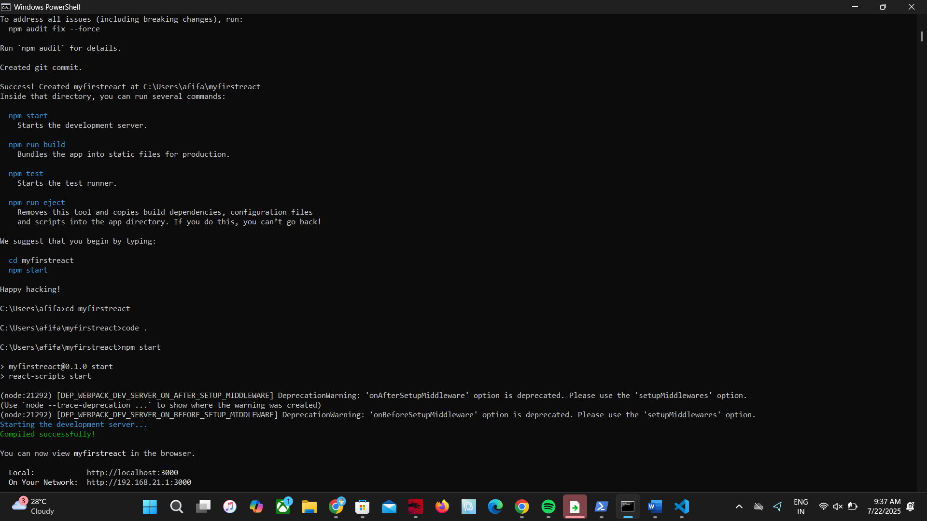

App.js:

import React from 'react';

*function* App() {

  return (

    <div>

      <h1>Welcome to the first session of React</h1>

    </div>

  );

}

export default App;

<http://localhost:3000>

